# Play: Effective Meetings: Video pre-alignment

## What is it:

Have you ever been in a meeting where the agenda wasn’t clear, the attendees weren’t on the same page or half the meeting was spent just explaining the purpose of the meeting? It’s not fun is it?

We hear you! You’re asking what could be done to do address this? Well today’s your lucky day as here’s a great play for having effective meetings by use of a simple pre-alignment video (don’t worry – its super simple).

This play is designed to ensure all attendees are aligned on the background and purpose of the meeting (or Scrum event) as well as bringing the attendees to the same level of knowledge.

Pro tip: Its recommended when adopting ***Video pre-alignments*** in your Team that you incorporate reviewing them before the meeting as a working agreement practice as the approach is only as strong as the weakest link (i.e. if 1 Team member doesn’t watch it, the need to be brought up to speed still)

This play refers to the guardrails:

* [Scrum Events](https://wiki.wdf.sap.corp/wiki/display/agiletrans/Scrum+Events)
* [Team Collaboration, Culture and Mindset](https://wiki.wdf.sap.corp/wiki/display/agiletrans/Team+collaboration%2C+culture+and+mindset)
* [Inter-team collaboration](https://wiki.wdf.sap.corp/wiki/display/agiletrans/Inter-team+collaboration)
* [Scrum Master](https://wiki.wdf.sap.corp/wiki/display/agiletrans/Scrum+Master)
* [Working Agreement](https://wiki.wdf.sap.corp/wiki/display/agiletrans/Working+Agreement)

## When to use it:

* This is a Martini play. ***Anytime, Anyplace, Anywhere***. Its always applicable and useful.

However, its particularly useful:

* As a reminder of what your Scrum events are for/how they are held (for new member ramp-up)
* As a pre-review of any complex issues that need to be discussed
* Whenever you want to speed up consensus on a proposal or idea

## Expected outcomes:

A team that is using Video pre-alignments effectively will exhibit the following characteristics:

* Members of the team who have reviewed the Video pre-alignments will be well prepared for the meetings
* Meetings where Video pre-alignments are used can get started and into productive meeting content quickly
* There will be early-warnings of significant misalignments on the subject matter meaning more time to react, plan and align
* Teams where Video pre-alignments are used can seek to iron our any significant misalignments ahead of the meetings
* Teams where Video pre-alignments are used have readily available reference material for others to search use and review

Pro tip: Ensure that the video is as short as feasible. < 5 mins ideally with a 10 min limit. The aim is to reduce the barriers (in this case time) to reviewing the content. It should be consumable in the time it takes to have a coffee.

Pro tip II: Make sure the video is sent out to the attendee’s with enough time to review ahead of the meeting (allowing for the various time zones)

## How to execute it:

* *Pre-requisite:* Book a meeting room or go to a quiet place to ensure the audio quality is good
* Recommend Initial Time: **5 minutes** (but depends on content)
* Recommended recurrence: Every time a meeting would benefit from pre-alignment. You can even re-use previous content.
* Examples of where it could be used: Roadmap review, Scrum event refreshers, complex issues, new ideas
* **For tracking:** If you use this play, please copy this as a User Story into your execution backlog:

**“ADCC Play: Effective meetings: Video pre-alignment”** as the title and label the jira issue: “**ADCC_Play**” The rest can be blank.

* Difficulty level: 2/5

### Team Video pre-alignment play

1. Log into your Skype meeting room
2. Clear or close all non-essential programs and tabs from your desktop to make it clear
3. Share your Screen (don’t forget this)

Pro tip: Do a quick 10 second recording then play back to make sure everything works as expected

1. Record your content focusing on the following:
   * Speak slowly and clearly
   * Having an appropriate introduction and ending (setting expectations as to what is required and when it is to be required)
   * Say only what needs to be said
   * Ensure the screen is clear and don’t move around the screen too quickly (as there may be a delay)
   * Let the audience know how to provide feedback
   * End the meeting once you have finished and ensure its <10 mins and ideally <5. *Re-record if it’s too long.*
2. Skype specific: Publish your recording and rename appropriately where the audience will understand the name
   * + This is good

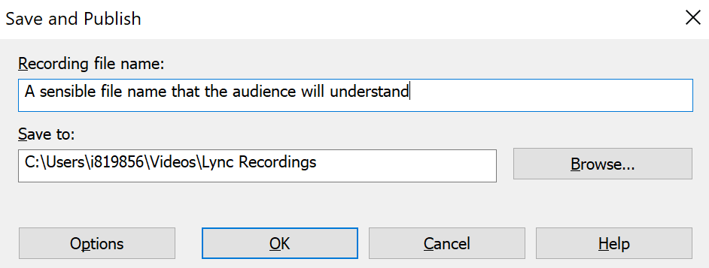

* + - This is not

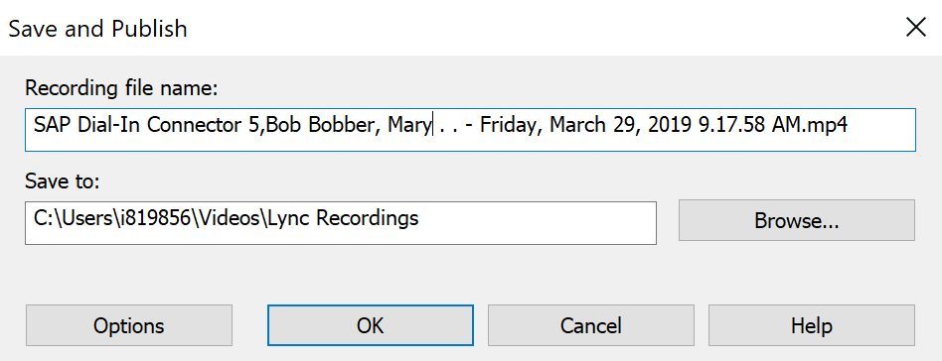

* + - So it looks like this:

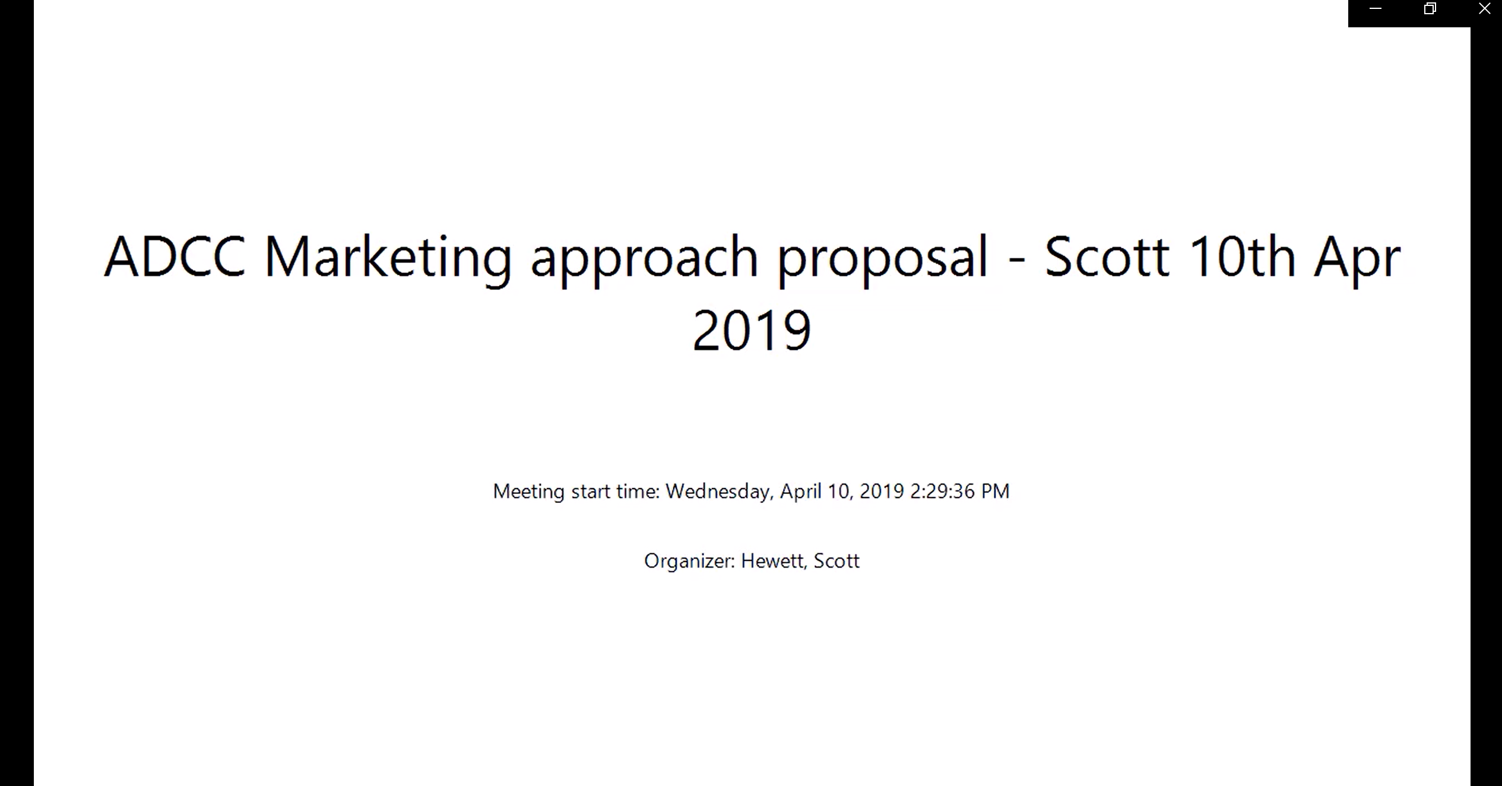

* + - NOT like this:

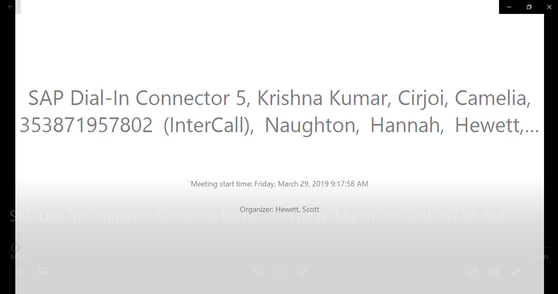

1. Use the appropriate **options**, usually just **Audio** content and **Presented content** but if you wanted to share your **Participant video** to get additional attention

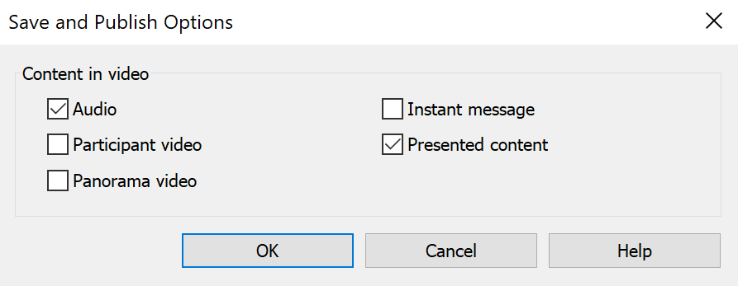

1. Once the video has finished publishing, load the video file into a location where **the entire audience** has access

* Ask someone to check that they have access before it’s sent out

1. Send your video out to the audience at an appropriate time ahead of the meeting being clear to outline what you are asking and that you need the colleagues to review the video ahead of time.

Pro tip: Let the audience know how long the video is so they know it isn’t an hour-long session (e.g. Please review this 4min 30 second video)

1. Start your meeting by validating the attendee’s have reviewed the content and ask for quick feedback on it (validating that they attendees have reviewed it)
   * You can always ask a few specific questions to be sure e.g:

* What did you think about part ***x*** or ***y***
* What did you take from the intro, or summary?

**Possible next steps to the** **Video pre-alignment play:**

To ensure you get the most out of this Video pre-alignment play look into the following possible behaviors:

* + Recording content not interesting
    - Is it too detailed or too hard to follow?
    - Is it not presented in an engaging way (monotone voice)
  + Recording content too long
    - Is the presenter saying only what needs to be said?
    - Is content being repeated?
  + Recording content not clear
    - Is it too small to see what needs to be seen?
    - Is the screen being moved around to quickly?
    - Can the presenter be heard clearly?
  + Team not reviewing video ahead of time
    - Is it clear to the Team why these pre-alignments exist?
    - Are the Team aware that the video exists?
    - How is the video being communicated?
    - Is there a commitment to review the content?
    - Is there a convenient way to review the content (is it mobile friendly)?